FlashPro Express Tutorial: Installing and Running

Created by: David Rubio G.
Blog: https://soceame.wordpress.com/
GitHub: https://github.com/DRubioG
Last modification date: 09/03/25

In this mini-tutorial I'm going to explain how to install and run FlashPro Express.
First of all, FlashPro Express is the software provided by Microchip to program their FPGAs/SoCs without the need to use Libero (which internally has an option to program the FPGAs).
Note: do not confuse FlashPro, which is the official Microchip debugging cable, with FlashPro Express, which is the software that allows you to program FPGAs/SoCs. Some boards do not need a FlashPro cable to program FPGAs with FlashPro Express, because it is already integrated.

Installation
The installation of FlashPro Express is supposed to come installed with the Full version of the Libero installer, so it is possible that you already have it installed. In case you do not have it installed, either because you have not installed Libero, you do not want to install Libero (because you are in a production environment) or it has not been installed with Libero, I will now explain how to do it.
First, we go to the FlashPro page and go to the Download Software section, and click on the link to install the stand-alone option.
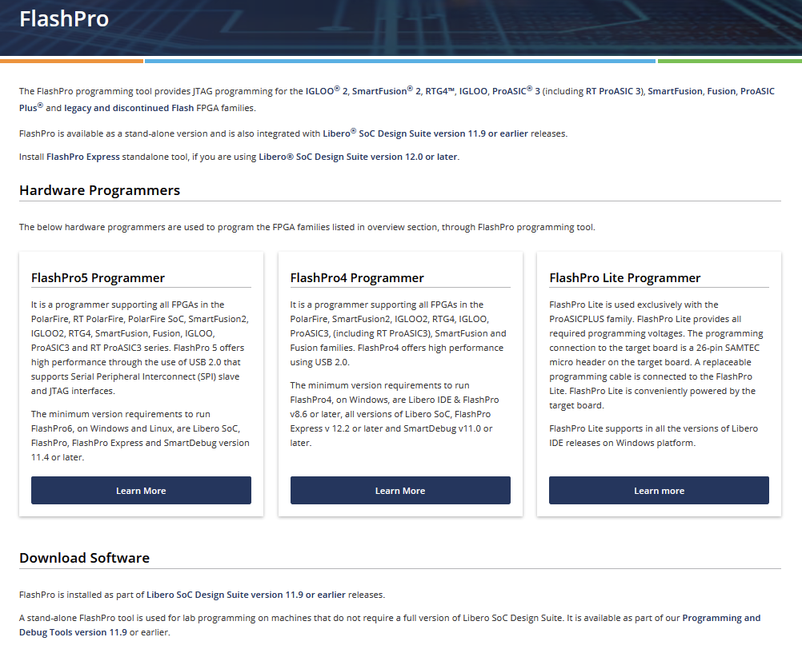
This takes us to the next tab, so now we click on the Lab Programming and Debug Tools option.
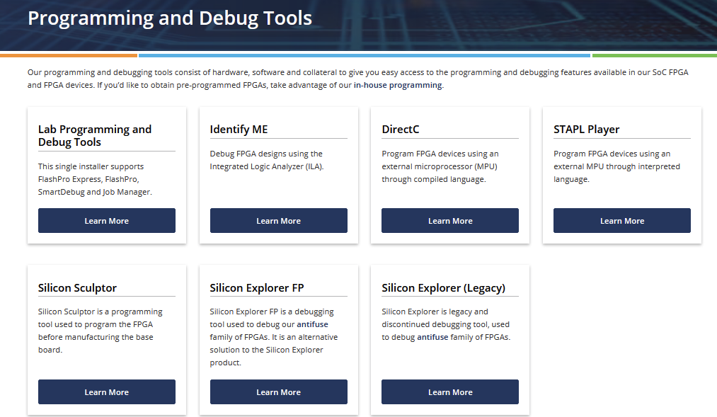
Now we are on the page where FlashPro Express is installed. It lets us choose the operating system on which we are going to install it.
When we click on it, the installer is automatically downloaded, without the need to have a Microchip account or an associated computer.
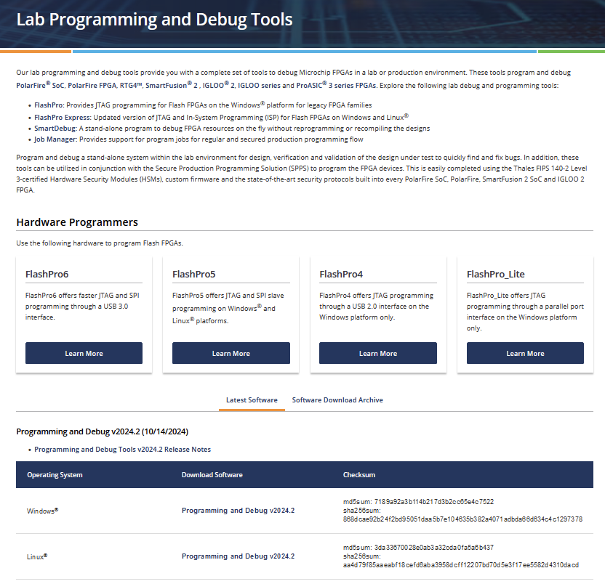
When we launch the installer, a download tab opens.
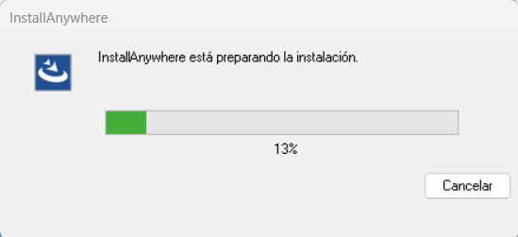
When it finishes, the installer appears with a warning that informs us that we have not launched it with administrator privileges, we decide to continue.
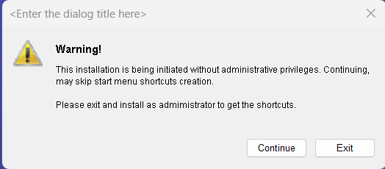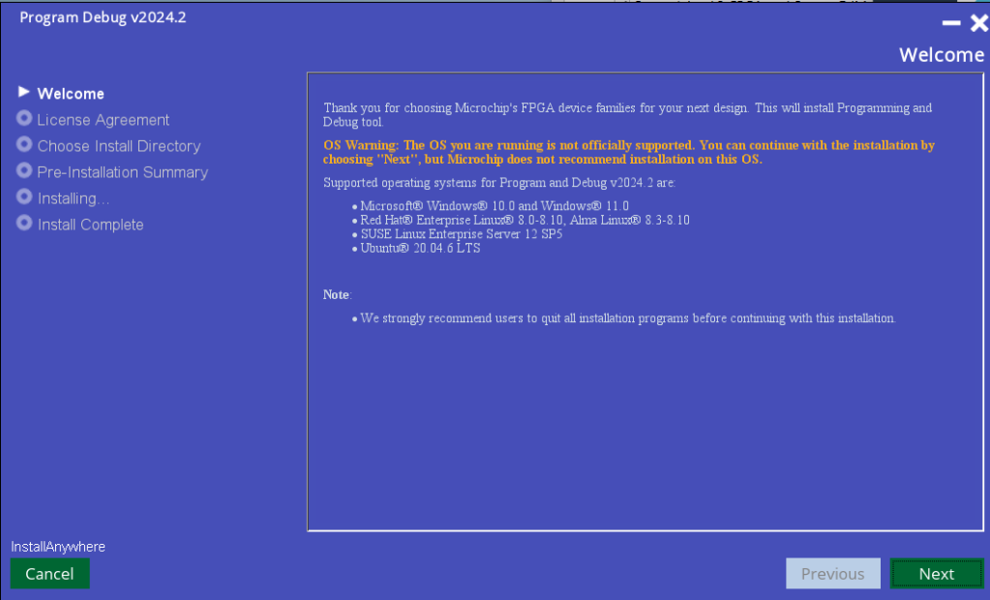
The next tab is the license, accept and Next.
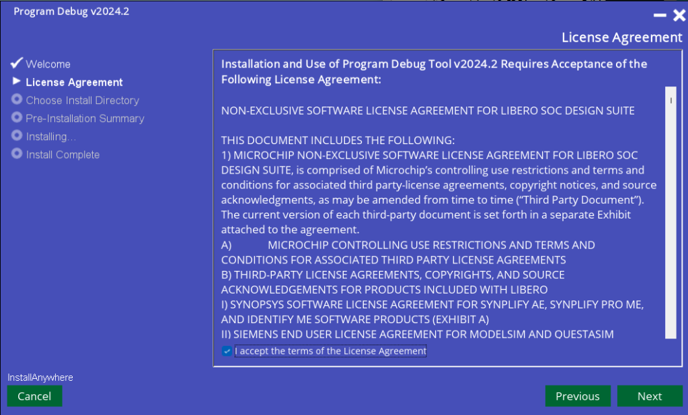
Then the place where it is going to be installed, Next.
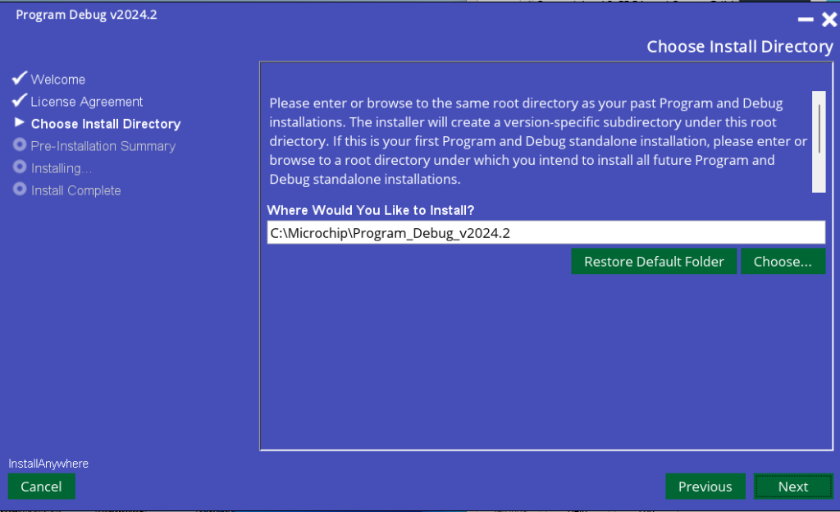
Then the information on how much it is going to occupy, Install.
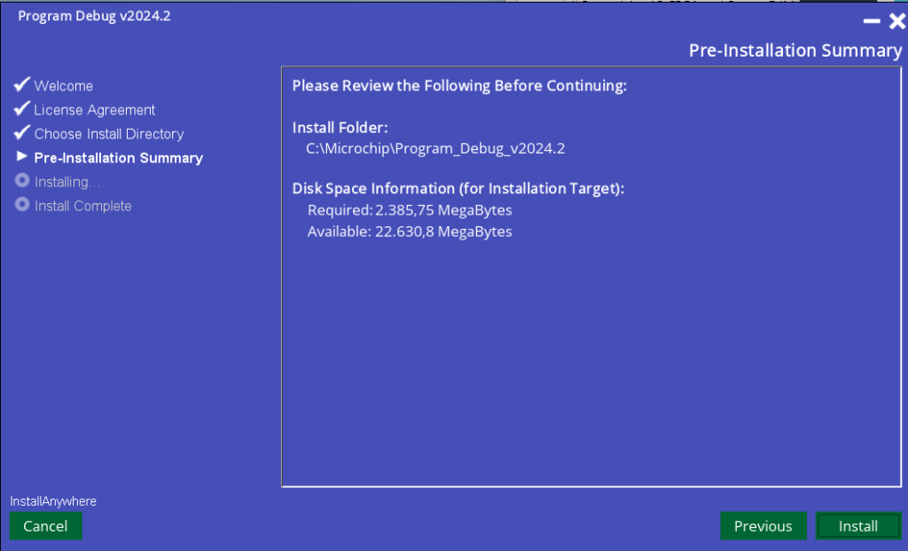
Then it begins to install, it is possible that it asks for administrator permissions.
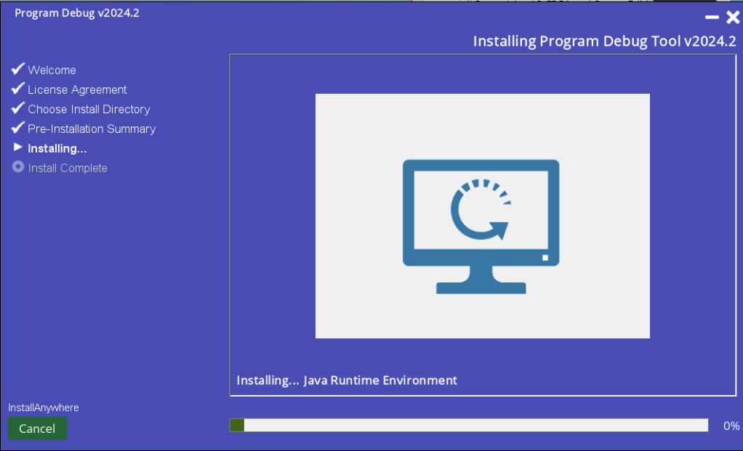
Once finished, we click Done.
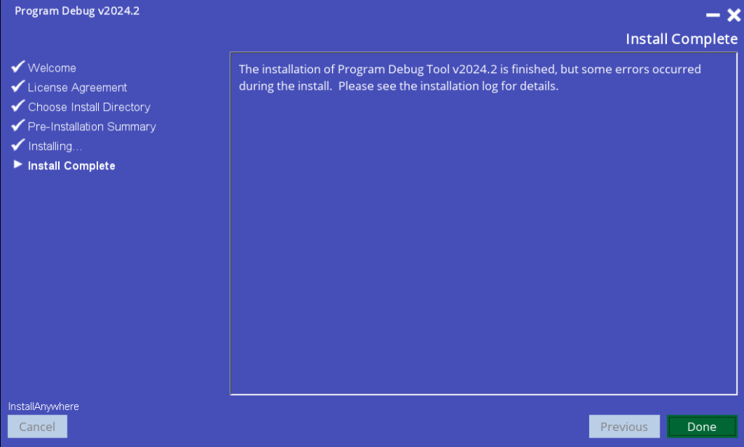
Now to search for it in the system it is called FPExpress (it is not called "FlashPro").
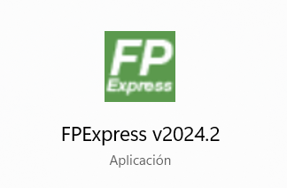
In case it does not appear it is in the bin folder within the installation path, in my case C:\Microchip\Program_Debug_v2024.2\Program_Debug_Tool\bin.
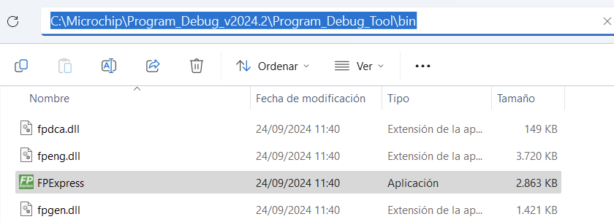
And if we launch it, FlashPro opens.
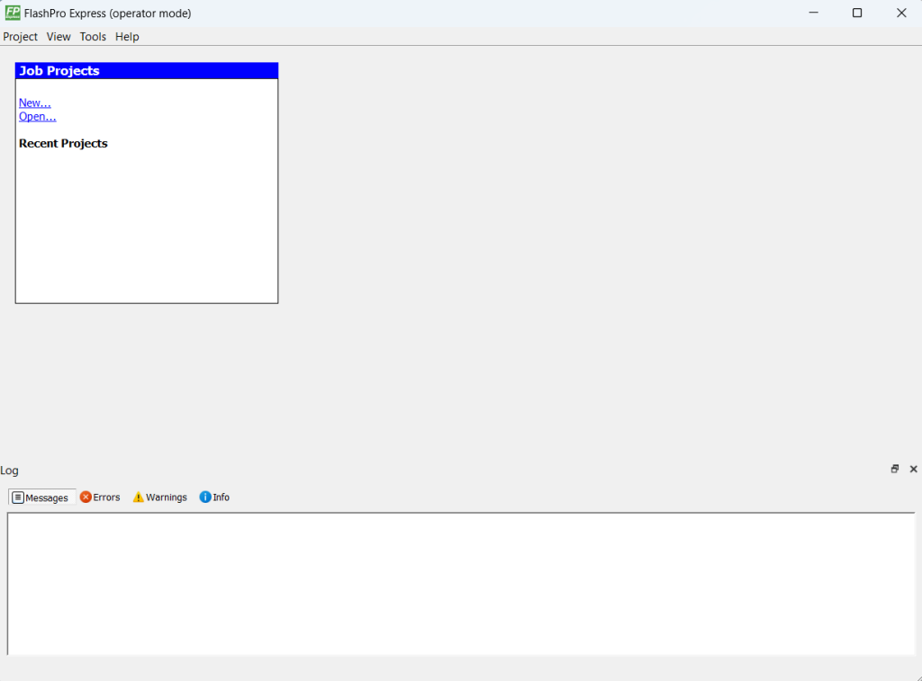

Running FlashPro Express
There are two options to use FlashPro Express: you can send us a FlashPro Express project from Libero (which is not really a project, but the information to create one), or you can send us just the bitstream. Microchip bitstreams have several formats, the most commonly used are .ppd and .stp.
All the export options are in Libero's Handoff Design for Production.
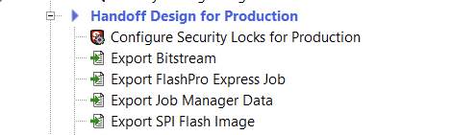

FlashPro Express Project
This way of working is the most recommended for production systems, because one project is created per bitstream. This option is not recommended for development because it generates a project for each bitstream.
To export a FlashPro Express project, you have to select the Export FlashPro Express Job option from Libero.
When you click on the option, a tab will appear asking you what you are going to call the project that is being exported and where you are going to save it. In addition, it will ask you what type of bitstream you are going to export.
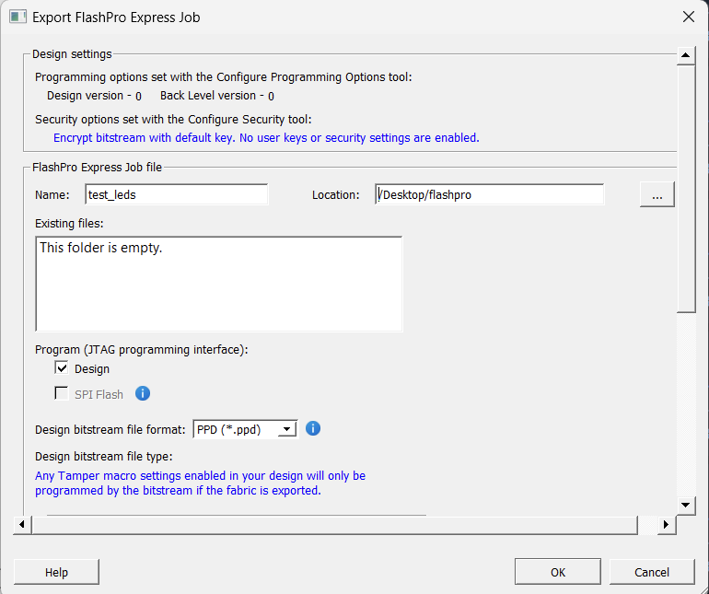
Once we click OK, we wait for it to export.
Once exported, it generates these two files.
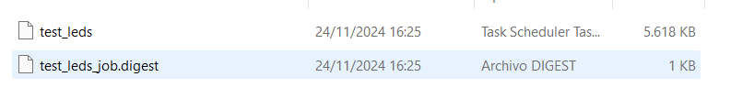
The next step is to open FlashPro Express.
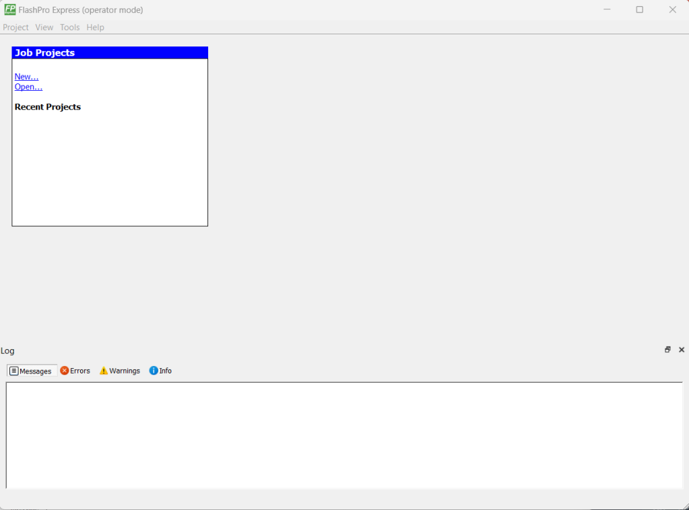
Now we tell it to create a project (New…) in FlashPro Express.
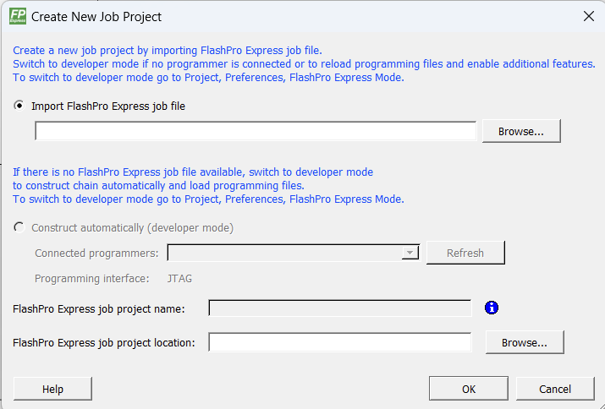
Now it will ask us to give it the project that we have exported from Libero, and also where it will create the FlashPro Express project.
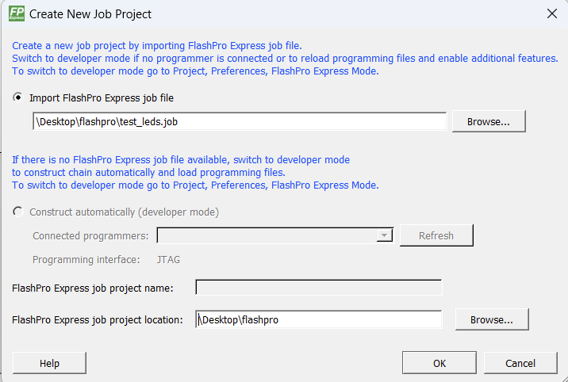
To launch FlashPro Express, it will ask us to connect the debugger cable or the board that has the debugger inside.
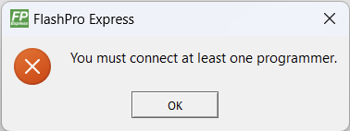
If we connect the debugger and open the project that has been created, FlashPro Express opens. Then, the serial number of the debugger appears.
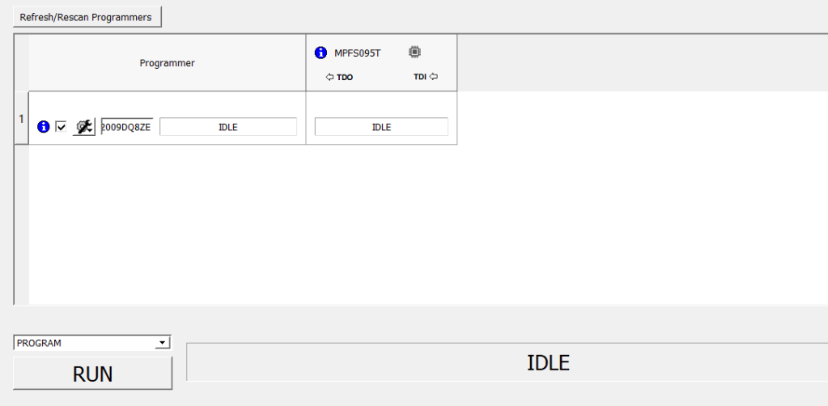
And in the tab below, the type of debugger that we are using appears.
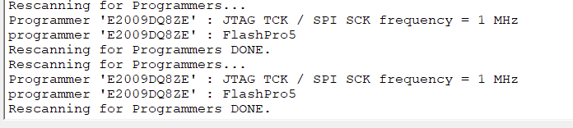
Also, there is a tab that gives us the different options that can be executed in FlashPro Express (Libero also allows us to use these same options). The ERASE and PROGRAM options are those that act directly on the operation of the FPGA, the rest are for obtaining information from the FPGA.
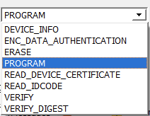
The option that interests us is the PROGRAM option, to program the FPGA (or the SoC, because the SoC can also be recorded, but the binary of the embedded SW part has to be within a bitstream, I will talk about this in another post). When you click on it, the recording operation begins.
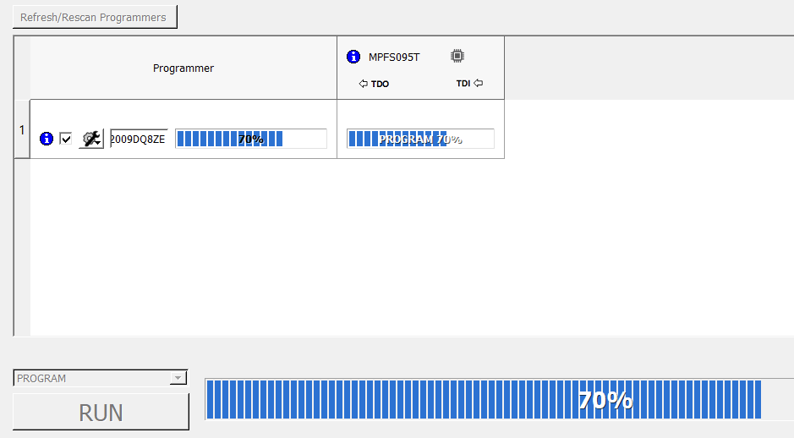
And when it finishes, it tells us if it has been recorded correctly, and with this the FPGA/SoC is programmed.
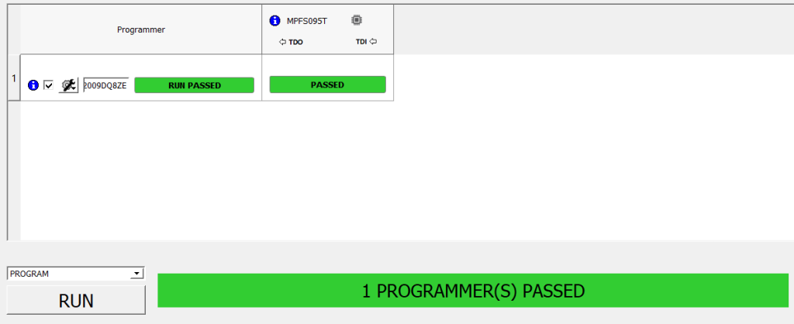
And with this the FPGA is programmed with a FlashPro Express Job.

Single bitstream
Now we go to the case in which you are given a loose bitstream. This option is the most recommended if you want to reprogram the FPGA continuously, because with a single project of this type you can record as many times as you want.
To do this, the first thing is to export the bitstream from Libero, in the Export Bitstream option. You only need to choose a bitstream format.
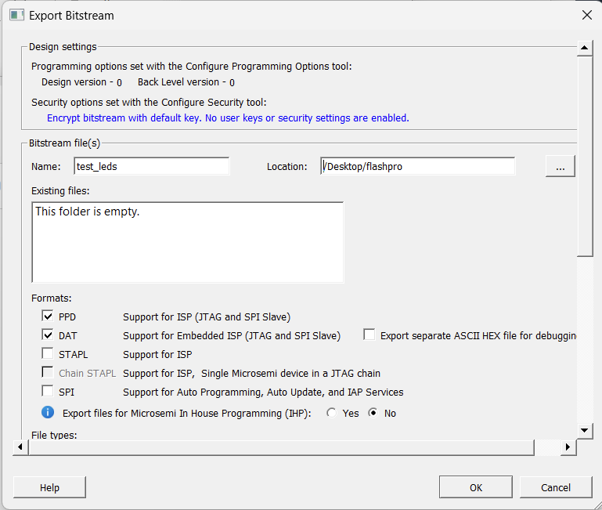
When exporting it, it generates two files per type of bitstream.
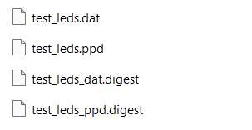
Now we go to FlashPro Express, and we see that the Construct automatically option is disabled. Well, what we have to do is enable it.
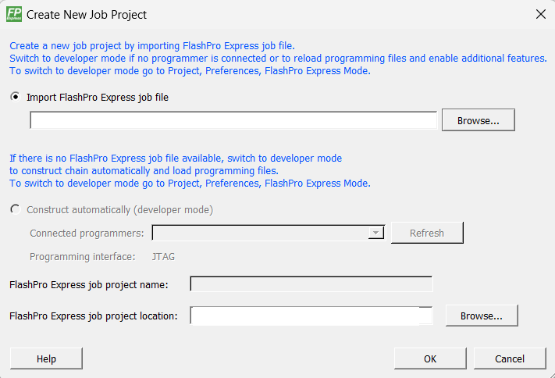
To activate it, we have to go to the Project tab and to Preferences.
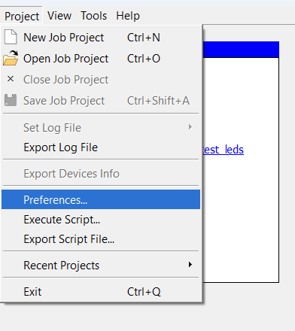
Now a tab opens, in the FlashPro Express Mode option we have to check the Allow job updates before programming (developer mode) option.
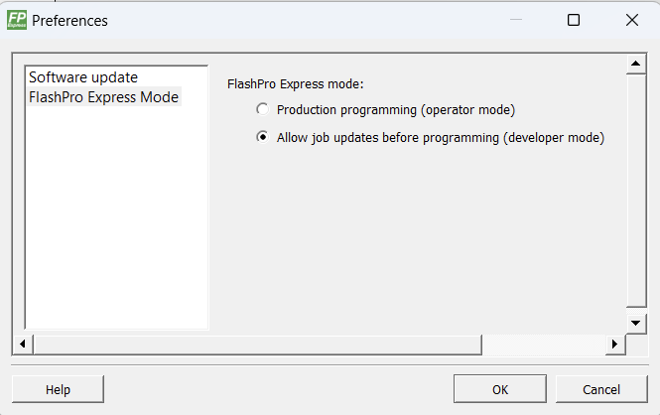
Once checked we can create a project in developer mode, we just have to pass the name of the FlashPro Express project and the location of the project.
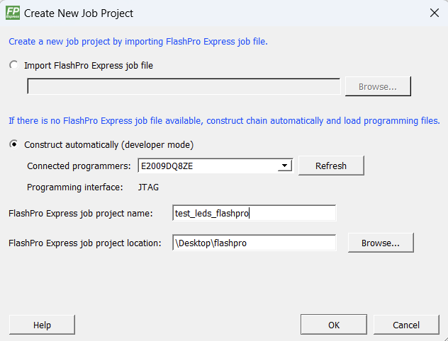
Now FlashPro Express opens but there is no bitstream selected to record. The type of device is recognized by the debugger.
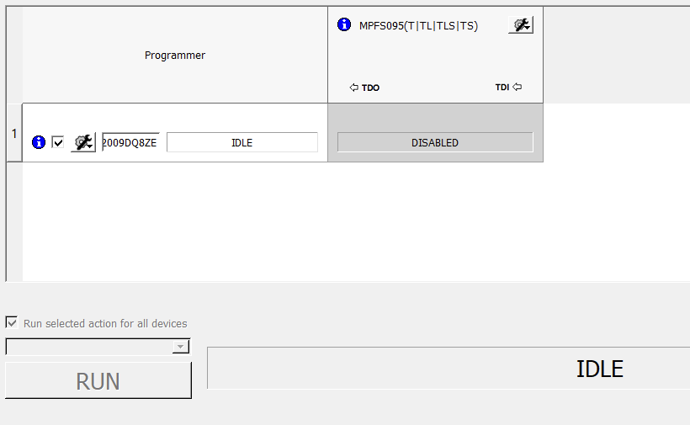
To indicate the bitstream to be recorded there are two options.
- In the name gear. First we mark the option Enable Device for Programming, and it will ask us to tell it which bitstream we want to record.
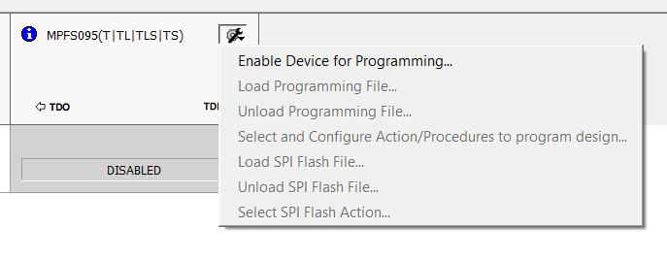
Once we tell it which bitstream we are going to record, it then tells us if we want the bitstream we are going to use to be recorded in the FlashPro Express project folder. This is a good way to keep version control, because with this way of programming we can change the bitstream as many times as we want to record it, while with the FlashPro Express Job we cannot change the bitstream every time we want to record it, but we will have to create a FlashPro Express project for each recording.
Now we can record the FPGA.
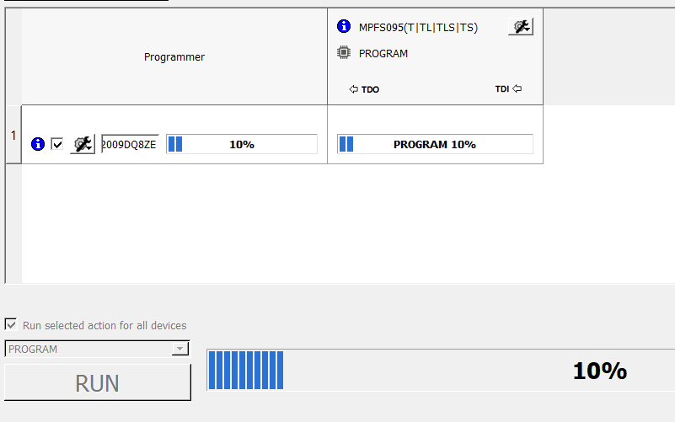
If we want to change the bitstream, all we have to do is go back to the gear and click on Load Programming File, and it will ask us for the new bitstream, and tell us if we want to copy it to the project folder.
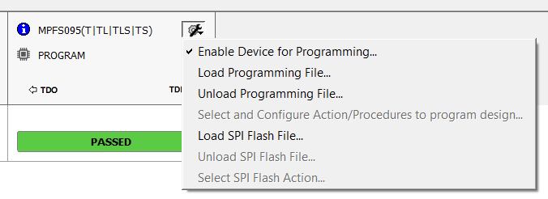
- In Tools. The Programming Connectivity and Interface option opens a tab.
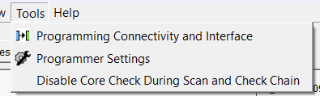
It opens a tab, which is the one that allows us to program chained devices.
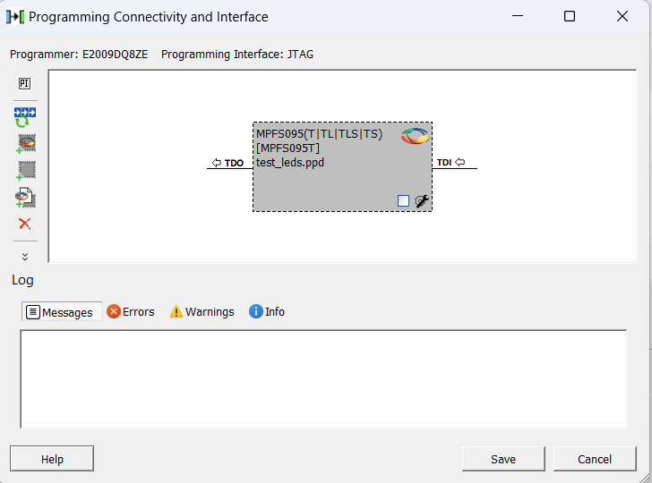
If we right-click on it, it allows us to enable the device to record or load a bitstream.
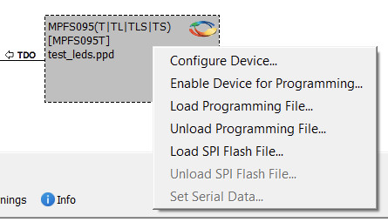
In order to record, the Enable Device for Programming option must be checked, either by this method or by the gear. It can also be enabled in the box that has the block.
And to choose the bitstream, just check the Load Programming File… option and select it.
When everything is done, the FPGA can be programmed.
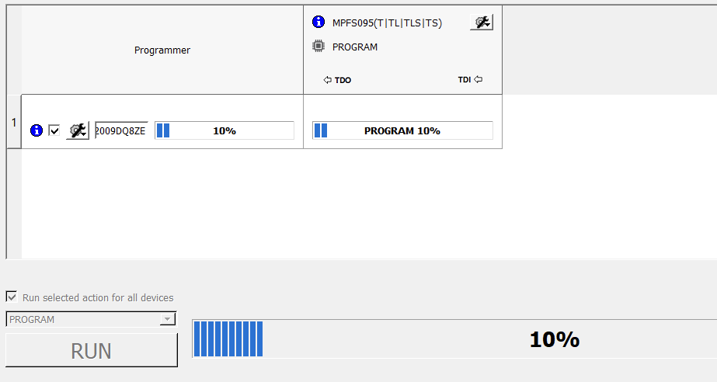

Final note
FlashPro Express can also be run by TCL commands through the terminal, which can be more useful for production, and it is programmed faster by commands, it just inv

